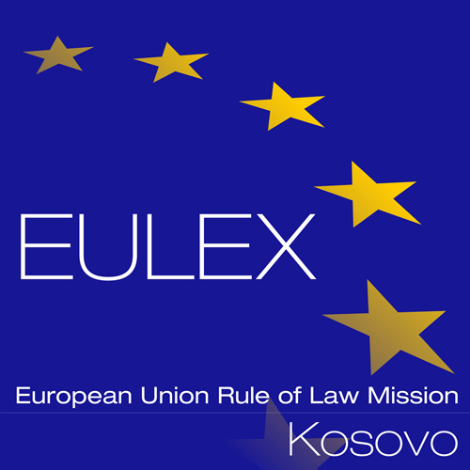

European Union Rule of Law Mission in Kosovo
EULEX Kosovo
Ndertesa Farmed
“Muharrem Fejza” p.n.
Lagja e Spitalit
10000 Pristina, Kosovo
www.eulex-kosovo.eu

CORRIGENDUM No. 1 to the Contract Notice

PUBLICATION REFERENCE: PROC/444/13/Ammunition and Job Specific Items (EuropeAid/135132/M/SUP/XK)

The following alterations and/ or corrections are made to the Contract Notice:
The former text:
16. Selection criteria
3) Technical capacity of tenderer (based on i.a. items 5 and 6 of the Tender Form for a Supply Contract)
(a) the tenderer has worked successfully on at least three (3) projects for the supply of ammunition in the past two years i.e. 2011, 2012 with a budget at least equivalent to that of its financial offer;
Shall read as new text:
16. Selection criteria
3) Technical capacity of tenderer (based on i.a. items 5 and 6 of the Tender Form for a Supply Contract)
(a) the tenderer has worked successfully on at least three (3) projects in fields related to the subject of these lots in the past two years i.e. 2011, 2012 with a budget at least equivalent to that of its financial offer;
The former text:
19. Deadline for submission of tenders
On 05 November 2013 at 15:00 hrs, (Kosovo time zone) at EULEX, Procurement Section, Main Warehouse Compound, Industrial Zone Veternik, (opposite Gorenje Hotel, next to fuel station), 10000 Pristina, Kosovo.

20. Tender Opening Session
On 05 November 2013 at 15:30 hrs, (Kosovo time zone) at EULEX, Procurement Section, Main Warehouse Compound, Industrial Zone Veternik, (opposite Gorenje Hotel, next to fuel station), 10000 Pristina, Kosovo.
Shall read as new text:
19. Deadline for submission of tenders
On 12 November 2013 at 15:00hrs, (Kosovo time zone) at EULEX, Procurement Section, Main Warehouse Compound, Industrial Zone Veternik, (opposite Gorenje Hotel, next to fuel station), 10000 Pristina, Kosovo.

20. Tender Opening Session
On 12 November 2013 at 15:30hrs, (Kosovo time zone) at EULEX, Procurement Section, Main Warehouse Compound, Industrial Zone Veternik, (opposite Gorenje Hotel, next to fuel station), 10000 Pristina, Kosovo.
All other terms and conditions of the Contract Notice remain unchanged. The above alterations and /or corrections to the Contract Notice are integral part of the Contract Notice.

